**Apple Watch Series 6 review**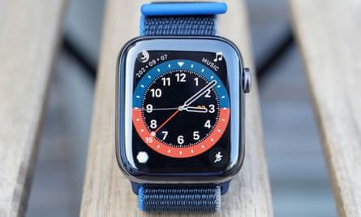

Photograph: Samuel Gibbs/*The Guardian*

**Introduction**

This report was requested by *The Guardian*. It investigates the new Apple Watch Series 6 and decides whether the new series of smartwatches is the best you can buy at the moment. It takes into account the information on the product provided by the manufacturer.

**Specifications**

* Case size: 40 or 44mm
* Case thickness: 10.4mm
* Weight: 30.5 to 39.7g or 36.5 to 47.1g depending on material
* Processor: S6
* RAM: 1GB
* Storage: 32GB
* Operating system: WatchOS 7
* Water resistance: 50 metres (5ATM)
* Sensors: gyro, HR sensor, blood oxygen, light, microphone, speaker, NFC, GPS/GNSS, compass, altimeter
* Connectivity: Bluetooth 5, wifi n, NFC, Ultra wideband, optional 4G requiring eSIM and compatible plan

**Facts and findings**

1. The Apple Watch Series 6 is the best smartwatch on the market for an iPhone.
2. It has better integration with the iPhone and is fast, fluid and responsive in a way that many rivals simply are not. It is extremely comfortable to wear and receives meaningful software and feature updates, and will do for an extended period of time.
3. It is best-in-class for general health-tracking functionality, makes most of it easy to use and understand.
4. Apple’s fitness activity tracking is very good. It will not beat a dedicated running or triathlon watch for battery life, utility, data or practicality but it is not so far off that more casual runners won’t be happy.
5. The problem for the Series 6 is that the previous Series 5 and Series 4 versions, and the new cheaper Watch SE, are just as good on this front.
6. The new blood oxygen sensor in the Series 6 is not that good; it just does not produce useful data in its current form unless you are going for altitude training.
7. The always-on screen is also noticeably brighter when not actively using it and the battery life will reliably last through a day and half. The Series 6 is also £20 to £50 cheaper than the Series 5 at launch.

**Conclusion**

It is not a massive upgrade over a Series 5 or even the Series 4 but the Apple Watch Series 6 is the best smartwatch you can buy right now if you use an iPhone.

**Pros**: excellent haptics, great always-on screen, great health tracking, great activity tracking, 50m water resistance, solid battery, comfortable, quick-swap straps, Apple Pay.

**Cons**: expensive, only works with an iPhone, sleep tracking not great, blood oxygen data not that useful.